HOW-TO FOR ADDING MARKERS AND POSTS
FOR INDIVIDUAL OBJECTS AND IMAGES TO
“OBJECT AND IMAGE MAP FOR
‘SENUFO: ART AND IDENTITY IN WEST AFRICA’” MAP

- ADD A NEW MARKER

Dashboard Maps Marker Pro Add New Marker

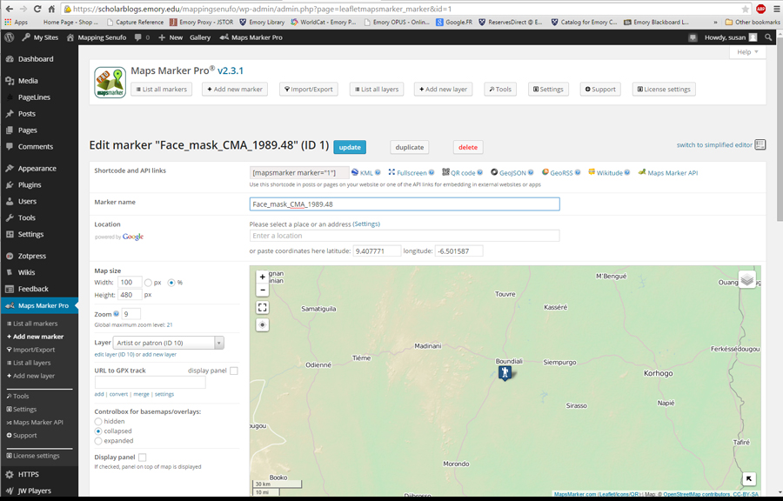

- ADD Marker Name
- DOUBLE AND TRIPLE CHECK the latitude and longitude information on the master database and also in the NGA GNS database; correct any inaccurate information in the database and any other related documentation
- ADD double- and triple-checked latitude and longitude for the corresponding location
- CHANGE MAP SIZE to 100% x 480 px
- CHANGE ZOOM to 9
- SELECT appropriate layer (e.g., Drawings, Photographs, Collection sites, Artist or patron; the layers listed here are the names of layers that relate to different kinds of place-based information, but we may identify other possible layers in future entries)
- UNCHECK Display panel so we do not see it at the top of the map

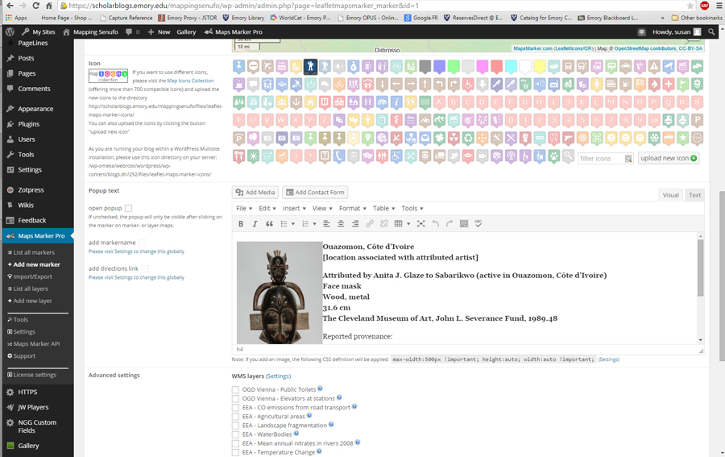

- SELECT appropriate icon for marker; the icon might relate to the type of place-based information associated with the marker (e.g., a specific place or general location for a drawing, photograph, collection site, or artist or patron)
- ADD tombstone text in the Visual field; select Text field if formatting is wonky and needs adjustment
- DOUBLE- AND TRIPLE-CHECK tombstone text against Senufo Unbound and the master database to make sure the information is correct; correct any inaccurate information in the master database and on the site
- INSERT associated image by selecting Add Media, choosing the image, selecting LEFT alignment and MEDIUM size
- CLICK Insert into post
- CLICK on the just inserted image and choose REMOVE LINK
- CLICK PUBLISH or UPDATE
- Keep the page open because there still are a few more steps involving this page, but first start to add a new post…

- ADD A NEW POST

Dashboard Posts Add New

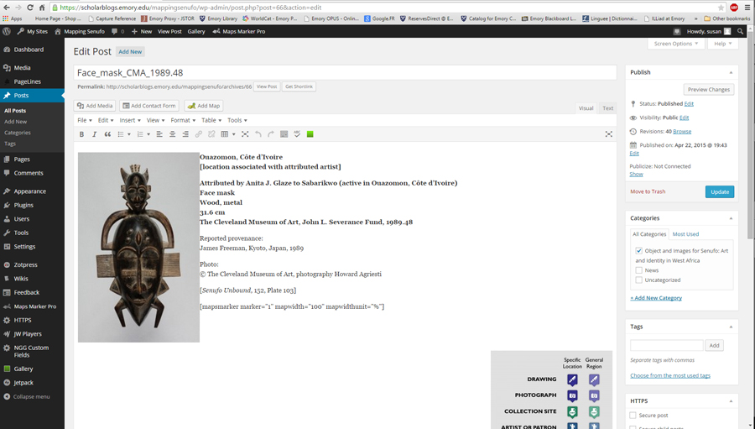

- ADD Marker Name (and it should be the same name as the name of the corresponding marker just produced)
- COPY tombstone information and image in the MARKER box and paste it into the POST box; make sure there are no extra spaces before the image
- DOULBE- and TRIPLE-check the tombstone information again; correct text in the MARKER, POST, and master spreadsheet as necessary
- CLICK on the image and select REMOVE LINK
- COPY mapsmarker information from the top of the corresponding MARKER page and paste it at the bottom of the tombstone information; adding this information links the MARKER page to the POST
- INSERT MAP KEY below the mapsmarker information by selecting Add Media, choosing the appropriate image (and make sure it is the one for posts!), selecting RIGHT alignment and MEDIUM size
- CLICK Insert into post
- CLICK on the just inserted image and choose REMOVE LINK
- SELECT appropriate category (e.g., Object and Images for Senufo: Art and Identity in West Africa”)
- INSERT associated image by selecting Add Media, choosing the image, selecting LEFT alignment and MEDIUM size
- CLICK on the image and select REMOVE LINK
- SCROLL to the bottom of the new post page and look for the FEATURED IMAGE box; select the FEATURED IMAGE that corresponds with the image in the post but formatted into a square
- CLICK PUBLISH or UPDATE

THERE ARE A FEW MORE STEPS:

Go back to the MARKER, add align the text “READ MORE” to the bottom of the marker text, and INSERT a link to the corresponding POST. CLICK UPDATE.

RELOAD the map and check that the information appears in all the right place and looks right in those places. CHECK the homepage, titles, individual object or image page, and the smaller maps. FIX any problems.

HERE’S THE OLD HOW-TO FOR ADDING MARKERS AND POSTS TO THE SITE (HECHT, 2015-05):

Adding entries to the Mapping Senufo site
- This process could be simplified if we had an excel sheet organized as follows:
  - Marker name
    - If a single object is going to have multiple markers (multiple possible locations associated with the object), list these as separate lines
  - Place code for that marker
  - Lat & long
  - Image filename
  - Marker icon type/category

- To add a new marker:
  - On the left side menu of the Wordpress Dashboard, click “Maps Marker Pro Add new marker”
  - Enter the marker name & place ID code (e.g., “Face mask, wood, metal - PLC_OB_IM_CMA_25”)
    - In the MS_CMA_OBJ_IMGS_W_PLC sheet, the marker name is associated with the MS_CMA_[DIGIT] code. Scroll across – the place ID is in the PLC_UNIQUE_ID_[DIGIT] column
  - Enter the lat & long coordinates (skip location name)
    - In MS_CMA_OBJ_IMGS_W_PLC, look at the row associated with this particular MS_CMA_[DIGIT] code. Scroll across to find the first PLC_UNIQUE_ID_1 column and remember the number in that cell – e.g., PLC_OB_IM_CMA_[DIGIT].
    - Go to the MS_CMA_PLC sheet, look for the relevant PLC_OB_IM_CMA_[DIGIT] row, and use those lat & long values.
    - Note that there may also be values in the columns PLC_UNIQUE_ID_2, 3, etc. This means that you have to create multiple versions of the same marker associated with different locations. You can do this by clicking the “Duplicate” button after you save the first marker, and then enter the new lat/long and save again with a new ID.
  - Select a zoom level. I’ve been using 9.
  - Set the map size to 100% x 480px
  - Uncheck the “Display panel” box.
  - Do not click the box to “open popup” or any other options. Leave the controlbox for basemaps/overlays set to “collapsed.”
  - Select the appropriate icon based on the marker category.
  - Enter the corresponding text from the Word document. Press Ctrl+Shift+V to paste as plain text, and then apply formatting like italics manually.
  - Place the cursor at the very beginning of the entry and click the “Add Media” button. Select the image corresponding to this object. The image filename can be found in the MS_CMA_OBJ_IMGS_W_PLC sheet in the IMG_file_name column, or in the text after the “===” line in the Word doc.
    - Select the following options when uploading the image: medium size, left alignment. Click the button to insert the image into the marker popup.
  - Click the blue “Publish” or “update” button to save your work.

- To create a grouping of markers (for example, if multiple locations are associated with one object):
  - First create each of the individual markers
  - Then in the left side menu, click “Maps Marker Pro Add new layer”
    - Name the layer something that will make sense to others working on the project. The layer name will not be visible on the site itself.
    - Enter lat/long coordinates or a location name that is central to the group of markers to be displayed.
    - Choose a zoom level.
    - Make sure the option to list the markers below the map is not checked.
    - When finished, click the blue “update” button to save your work.
  - Now go back to the list of all markers. Edit the settings for each of the markers to be included in this group, and assign them to this layer. You may wish to go back and re-edit the zoom or lat/long settings for the layer after adding the markers to make sure it displays nicely.

- To add a new post associated with that marker:
  - On the left side menu of the Wordpress Dashboard, click “Posts Add New”
  - Enter the marker name/ID code
    - associated with MS_CMA_[DIGIT] codes in MS_CMA_OBJ_IMGS_W_PLC sheet
  - Enter the corresponding text from the Word document. Press Ctrl+Shift+V to paste as plain text, and then apply formatting like italics manually.
  - Place the cursor at the very beginning of the entry and click the “Add Media” button. Select the image corresponding to this object. The image filename can be found in the MS_CMA_OBJ_IMGS_W_PLC sheet in the IMG_file_name column, or in the text after the “===” line in the Word doc.
    - Select the following options when uploading the image: medium size, left alignment. Click the button to insert the image into the post.
  - On a new line after the end of the text, enter the shortcode for the marker or group of markers associated with this object – e.g., [mapsmarker marker="11"] or [mapsmarker layer="11"]. You can find these codes if you go to Maps Marker Pro List all markers (or layers), in the right-most column of the list.
  - Once this is done, scroll down – on the bottom right hand corner of the page, there is a panel for “Featured Image.” This is the image that will show up in the scroller on the home page. Click the link to “Set Featured Image.”
    - You can select the same image you just inserted into the post, and Wordpress will automatically crop it to produce a square. If you don’t like how it is cropped, create your own square version of the image using a program like Photoshop.
  - Click the blue “Publish” button to save your work and publish the post to the site. If you want to save without publishing, click “Save as draft.” If you make changes and want to save them, click the “Update” button.

