HOW-TO: MAPPING SENUFO MAIL MERGE
In Windows version of Microsoft Office 2013, create a new Word document
Under the ‘MAILINGS’ tab, Start Mail Merge -> Step-by-Step Mail Merge Wizard
Mail Merge Wizard appears on the right side of the document
Step 1: Pick ‘Labels’, and click ‘Next…’ to proceed
Step 2: Choose ‘Change document layout’, in ‘Label Options’ window, click the ‘Details’ button in lower left corner to adjust the label layouts according to needs (Attention: label height plus top margin cannot exceed page height and label width plus side margin cannot exceed the page width. For this project, recommend Top margin: 1”; Side margin: 1”; Label height: 7.5”; Label width: 5.5”; Number across: 1; Number down: 1), ‘Ok’ and ‘Ok’ to save the changes
Step 3: ‘Use an existing list’, click ‘Browse…’, choose the Excel spreadsheet to merge
Step 4: Look back at the ‘MAILINGS’ tab, under ‘Insert Merge Field’, names of all the columns from imported spreadsheet should appear, click on them to insert them into the label. Column names come in « » on the page, arrange them and type like on a typical document (whatever information on this page will appear on all the labels). ‘Next…’ when satisfied.
(5 June 2015: Here are the mail merge fields to use for “OBJECT AND IMAGE MAP FOR "SENUFO: ART AND IDENTITY IN WEST AFRICA.”)
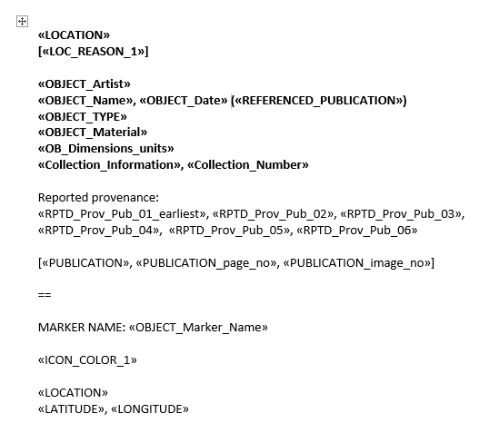
Step 5: Preview the labels. Click on left and right arrows under ‘MAILINGS’ tab or in the Wizard to switch from one label to another. Go back to previous steps to make changes if needed.
Step 6: Click on ‘Edit individual labels…’ to get a new document with merged information.
Step 7: In the new document, modify individual labels according to needs. Save it.
(5 June 2015: For the “OBJECT AND IMAGE MAP FOR "SENUFO: ART AND IDENTITY IN WEST AFRICA,” here is a list of some but maybe not everything to adjust in the Word document.)
- Change the font to Gill Sans MT, 12 point.
- THIS STEP IS CRITICAL: Double-check the LATITUDE and LONGITUDE for each and every place. Word may show more decimal points than it should. The coordinates in the Excel spreadsheet are the ones to use.
- Italicize publication titles, e.g., Senufo Unbound.
- Check punctuation, i.e., quotation marks, commas, and other marks that may not have transferred correctly.
- Check accents to make sure they transferred correctly.
- When changing typos on the Word document, also change them in the Excel spreadsheet.
Save the original Word document as well for future changes. But once closed, the Excel spreadsheet imported should be kept together with this Word document to ensure it could be open normally, because this document only deals with the merging process, does not store the actual information. (5 JUNE 2015: Or you can reselect the Excel spreadsheet to use for the mail merge.)

